Design Research

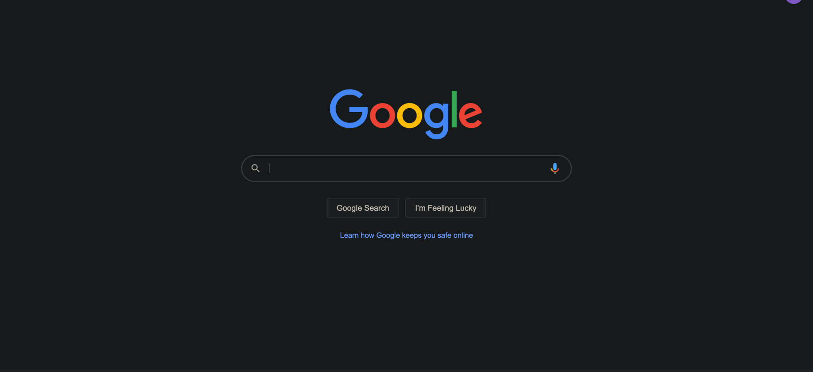

For a search bar, [Google](https://www.google.com/) gives something which is extremely simplistic, easy to view and access. We decided to have a clean interface like google with some tweaks, like adding a placeholder text in the search box and a prominent “submit” button near it, this would give the user a clear indication of where to start the check-in process, in the case of our particular application. For the mobile app version, we would also implement a camera feature to scan an unique QR code to check-in into a particular location.

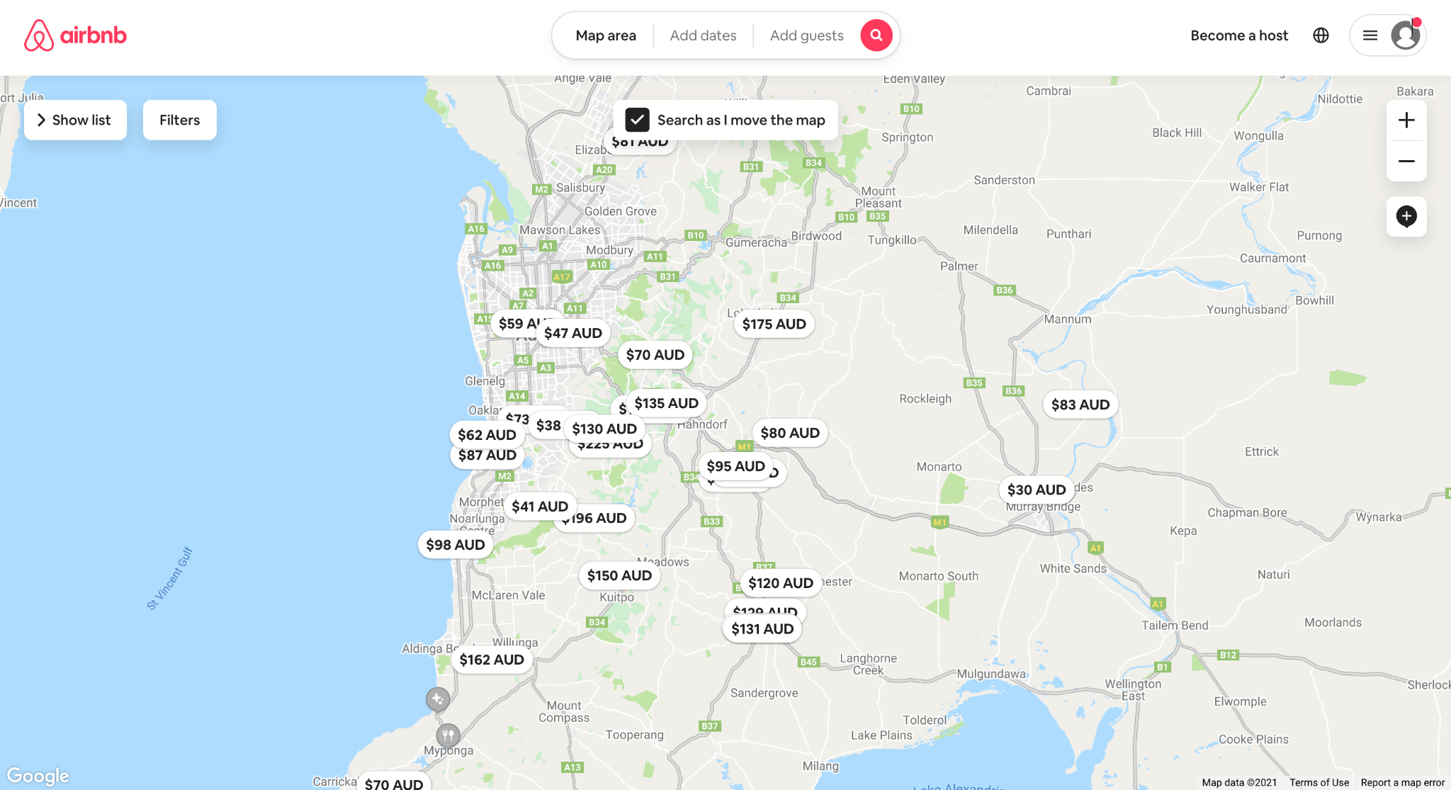

For the map feature, [airbnb](https://www.airbnb.com.au/) has a great interface, they have given the entire screen for the user to interact with the map, while making the header minimal yet easy to access whenever needed. The zoom in and out functionalities are also very important in our cases as we want to be very specific for highlighting any hotspots. We have also added a scale to our map which will also make highlighting hotspots more precise.

The header on its own is used to provide great functionality to the websites, we found it useful as a navigator, so that when a button is clicked it directs the user to that respective part of the page.

## Manager Home Page (Check-In table)

For the manager/venue home page, we needed an interface to show the visitor check-ins and the relevant details related to the check-ins. The first website that fetched out attention was [https://guesttrack.com.au](https://guesttrack.com.au/). The picture attached above shows the layout that they use to show the visitor check-in. The simple interface they use makes it very easy for the user to navigate and check all the important details without much effort. That is why we decided to base our design on their structure to make our interface user-friendly.

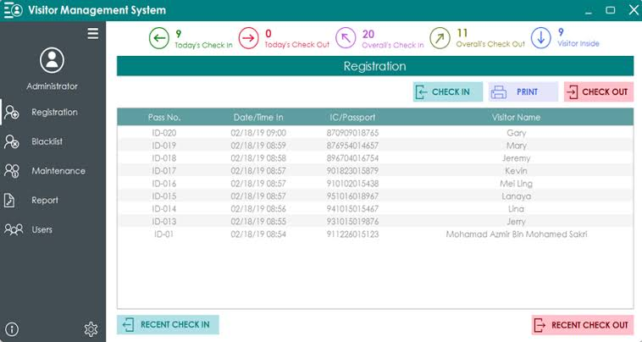

Another website we looked at for the check-in system was [https://www.snm.my.panasonic.com](https://www.snm.my.panasonic.com/). The picture attached above shows the visitor management system of Panasonic System Network Malaysia. Their design is a bit more complex to that of Guest Track, but it also helped to attain a good idea of what data we need to show in the records.

Firstly, I choose to refer to the most common login interface in our daily life, which is https://login.adelaide.edu.au. It is undeniable that it creates a very clear and clean login page. Under the Login header, the important thing is to enter the username and password. It also provides a simple example in the username input to prompt the user, and it prompts the user below the login. Then, also on the corresponding side, there are areas with Help and Service Status for users to use more efficiently. But we were different in that we needed an option that made it easier for users to register, so we looked at another page which is the login page of steam. (https://store.steampowered.com/login/)

Similarly, for pages, it is also very simple and efficient. It also creates a very good environment for users, like the background colour. And it also provides the option to register, which could jump directly to the register screen. In addition, more details are provided in the Head Bar so that users can use it more efficiently.

After looking at the login interface, it directly for its registration interface was viewed, which is https://store.steampowered.com/join/. In the overall first interface, only the relatively important login information and the region classification, as well as the minor policy statement are retained. Although the registration interface was not fully displayed, the corresponding information was gradually completed in the following steps. Also, the Burger Button at the top of the screen effectively lets users switch between the pages they want.

Also, I have checked more registration interfaces to get more comprehensive information. For example, in the example below, we see the login interface of SurveyMonkey (https://www.surveymonkey.com/user/sign-up/), in the interface design, it also designed a simple and efficient registration screen with different is it set up some name before the input in the first interface and jump back to login screen option and set up the correlation of different social media options.